# Team Project Instruction

## Himalia

### CyberPoetrySlam Operation Instructions:

**Start Application:** 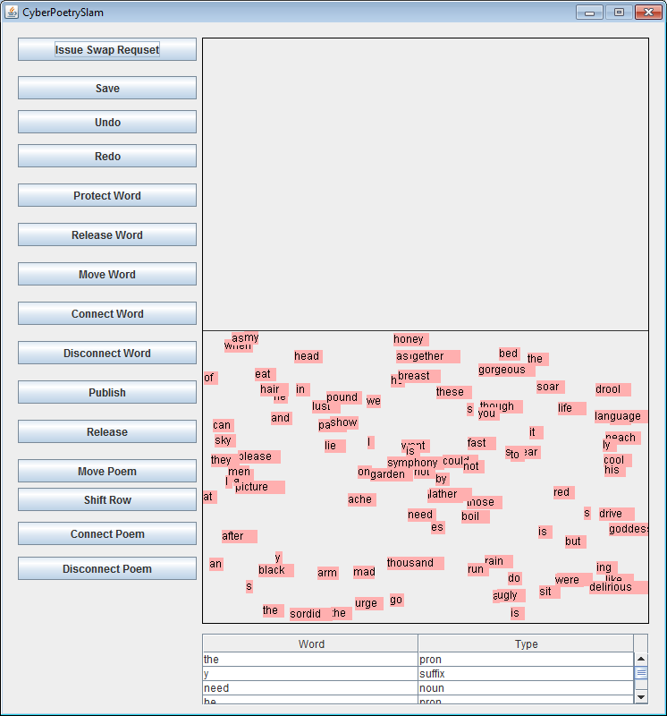

After the application is started, we can get an interface as above. There are fourteen buttons for different functions: Save, Undo, Redo, Protect word, Release word, Move Word, Connect Word, Disconnect Word, Publish, Release, Move Poem, Shift Row, Connect Poem, Disconnect Poem. There’s a region panel which contains two parts, the upper one represents Protected Region, and the lower one represents Unprotected region. There’s a Word Table below the panel.

General Instruction:

For every action in the panel, we need to click the corresponding button first.

**Save:**

Click button “Save” the state of the panel will be saved. On the other hand, the program has memento, so every time the program is closed, it will store the state of the panel. Then what does “Save” do? It can deal with abnormal closure of the system. The “abnormal” shut down may not be available. We can test it in another way. Generally, when we start an application, make some changes, and then create a new application, the new application will not show the changes. If we start an application, make some changes, click “Save”, and then create a new application, the modification will be shown on the new application.

**Protect word:**

There are two steps to protect a word: Before we protect a word, we must click on the button ’Protect a word’. After that, we can select a word in the unprotected region by left clicking with the mouse, drag it to the protected region, and release it.

There are some cases that are not allowed, list as following:

|  |
| --- |
| 1. Mouse didn’t click on a word |
| 1. Drag a word and released it in Unprotected Region. The word will return back to its original position |
| 1. Drag a word and released it in protected Region, but it overlaps with some words or poems. The word will return back to its original position. However, overlapping while dragging is allowed. |

**Release word:**

When we want to unprotect some word, we need to click on the ‘Release word’ button. Then we can select a word in protected region, and drag it to the unprotect region.

There are some cases that are not allowed, list as following:

|  |
| --- |
| 1. Mouse didn’t click on a word |
| 1. Drag a word and released it in protected Region. The word will return back to its original position |
| 1. Mouse click in the unprotected region |

**Connect Word:**

We need to click on the button of ‘Connect Word’ before we connect any word. After that, we can select a word in the protected region, and drag it and make it overlap with the word/poem to which an edge word is to be connected. Drop the word on the side of the word/poem where the connection is desired to be.

There are some cases that are not allowed, list as following:

|  |
| --- |
| 1. Drag a word and released it in protected Region, but the word doesn’t overlap with more than one object. The word will return back to its original position |
| 1. Drag a word and released it in protected Region, but the word doesn’t overlap with anything. The word will return back to its original position |
| 1. Mouse didn’t click on a word |
| 1. Mouse click in the unprotected region Mouse didn’t click on a word |

**Move Word:**

We need to click on the button of ‘Move Word” before we move any word in either Protected or Unprotected region. After that, we can select a word in a region, and drag it to the destination position.

There are some cases that are not allowed, list as following:

|  |
| --- |
| 1. Mouse click on a word in a region and release it in another region. The word will return back to its original position |
| 1. Mouse click on a word in protected region and release it with overlapping. The word will return back to its original position |
| 1. When dragging word around, the word cannot pass the boundary between protected and unprotected regions. |

**Move Poem:**

We need to click on the button of ‘Move Poem’ before we move any word. After that, we can select a word in a region, and drag it to the destination position.

There are some cases that are not allowed, list as following:

|  |
| --- |
| 1. Mouse click on a Poem in a region and release it in another region. |
| 1. Mouse click on a Poem in protected region and release it with overlapping |
| 1. When dragging word around, the Poem cannot pass the boundary between protected and unprotected regions. |

**Disconnect Word:**

We need to click on the button of ‘Disconnect Word’ before we want to disconnect any edge word from a poem. After that, we can select a word the edge of the poem, and drag it to separate it from the poem.

There are some cases that are not allowed, list as following:

|  |
| --- |
| 1. If the disconnected word is released and overlaps with another object in protected region, the word will not be disconnected from the poem. |
| 1. If the disconnected word is released in unprotected region, the ‘disconnecting word’ will not be executed. |

**Undo:**

If you don’t like the previous operation you have made, you can click the undo button to make the system to the previous state.

There are some cases that are not allowed, list as following:

|  |
| --- |
| 1. If you publish a poem, you can’t undo it. And you cannot undo to any of the previous state. |

**Redo:**

When you have done undo, you can click on the “Redo” button to do make it done again.

There are some cases that are not allowed, list as following:

|  |
| --- |
| 1. You can only redo when you have done undo in the previous state |

**Publish:**

You can click on the “Publish” button before you want to publish any poem, after you click on the button, you can click on any poem in the protected region to make it published on a wall.

There are some cases that are not allowed, list as following:

|  |
| --- |
| 1. If there’s no poem in the protected region, you can’t publish the Poem |

**Release:**

You can click on the “Release” button before you want to Release any poem, after you click on the button, you can click on any poem in the protected region to make the words in the list to be released randomly into unprotected region.

There are some cases that are not allowed, list as following:

|  |
| --- |
| 1. If there’s no poem in the protected region, you can’t release the Poem |

**Shift Row:**

You can click on the “Shift Row” button before you want to shift a row from a poem, after you click on the button, you can click on a Row from a Poem in the protected region and drag it left or right to change the Row’s position, you can’t drag a row out of the poem.

There are some cases that are not allowed, list as following:

|  |
| --- |
| 1. When you shift a row, it doesn’t allow overlapping with other objects |
| 1. You can also shift a poem with single row |

**Connect Poem:**

When you want to connect two poems, you can click on the “Connect Poem” button and then drag a poem from the protected region and released it to another poem, then the tow poem will be connected top/bottom according the position you released, you can also connect a single word to the top/bottom of the row.

**Disconnect Poem:**

When you want to disconnect two poems, you can click on the “Disconnect Poem” button and then click on a row in the poem and drag it out of the Poem, if the row is from the top/bottom, the single row will be disconnect, if the row is in the middle of the poem, the poem will be disconnect into three parts.

**Word Table**

You can sort the wordlist by word or by type. When you click on a word in the list, a corresponding word will be highlighted.